**Chapter 9: Interactive Schedul-**

**ing**

**Purpose and Scope of Interactive Scheduling** Schedule changes occur during the work day. Keeping the schedule up to date is essen- tial to maintain its quality and cost effectiveness. To accomplish this, Optibus OnSched-

ule™ provides an interactive manual editing facility. In addition, the manual editing

facility enables you to fine-tune the schedule.

This chapter shows you how to open elements in the Gantts for editing and make changes using their information boxes. Most manual editing will be on the Drivers Gantt. Edits to the Vehicles Gantt are limited. You can only reschedule a trip in the Vehicles Gantt for a Vehicles-only schedule.

What follows will be based on editing the Drivers Gantt for a full schedule. At the end of the chapter there is a short section on editing the Vehicles Gantt elements for a

Vehicles-only schedule.

You can test your edits one at a time. At any point you can save or discard your changes. The following editing actions available that can be used alone or in combination:

*Table 9-1: Interactive Editing Functions for a full schedule*

|  |  |  |  |  |
| --- | --- | --- | --- | --- |
| **Function** | **Drivers** | | **Vehicles** | |
| **Available** | **Reference in Purpose and Scope of Interactive Scheduling** | **Available** | **Reference in Vehicles Gantt**  **Interactive Editing** |
| Move a trip to another  Duty | Yes | **Moving a trip to another Duty** | N/A |  |
| Change trip times | Yes | **Changing trip times** | Yes | **Purpose and Scope of**  **Interactive Scheduling** |
| Delete a trip | Yes | **Deleting a Trip** | Yes | **Deleting a trip** |
| Changing a Depot Pull out/Pull in | Yes | **Changing a Depot**  **Pull out/Pull in** | N/A |  |
| Adding and Removing a Taxi | Yes | **Adding and Removing a Taxi** | N/A |  |
| Replacing a Taxi with a  Deadhead | Yes | **Replacing a Taxi with a Deadhead** | N/A |  |
| Custom Types and Ele- ments | Yes | **Custom Types and Ele- ments** | No |  |
| Block functions |  | | | |
| Block ID | Yes | **Purpose and Scope of Interactive Schedul- ing** | Yes | **Changing a Vehicle ID** |
| Start/End stops | Yes | **Changing Duty**  **Start/End stops** | No |  |
| Vehicle type | N/A |  | Yes | **Changing a Vehicle Type** |
| Move block up or down | Yes | **Purpose and Scope of Interactive Schedul- ing** | Yes | **Moving a block up or down** |
| Create a new trip | **Purpose and Scope of Interactive Scheduling** | | | |

*Table 9-2: Interactive Editing Functions for a vehicles-only schedule*

|  |  |
| --- | --- |
| **Function** | **Reference in Purpose and Scope of Interactive**  **Scheduling** |
| Move one or more trips to another vehicle | **Purpose and Scope of Interactive Scheduling** |
| Change trip times | **Purpose and Scope of Interactive Scheduling** |
| Delete a trip | **Deleting a trip** |
| Change a Depot Pull out/Pull in | **Changing a Depot Pull out/Pull in** |
| Custom Types and Elements | **Custom Types and Elements** |
| Block functions |  |
| Block ID | **Changing a Vehicle ID** |
| Vehicle type | **Changing a Vehicle Type** |
| Move block up or down | **Moving a block up or down** |
| Create a new trip | **Purpose and Scope of Interactive Scheduling** |

**Preparing for an Interactive Scheduling Ses- sion**

At the top of the Gantt display, you will have noticed that there is an option to save or dis- card your changes, for example after setting preferences or running an optimization:



The same applies to manual editing. Until you feel comfortable using manual editing, we suggest that you start by backing up your existing schedule using **Save As** from the  Context Menu.

To enter Manual Editing mode, click the  Manual Edit button in the top toolbar. An editing area (in the red box) called the **stack**, opens above the regular Gantt:

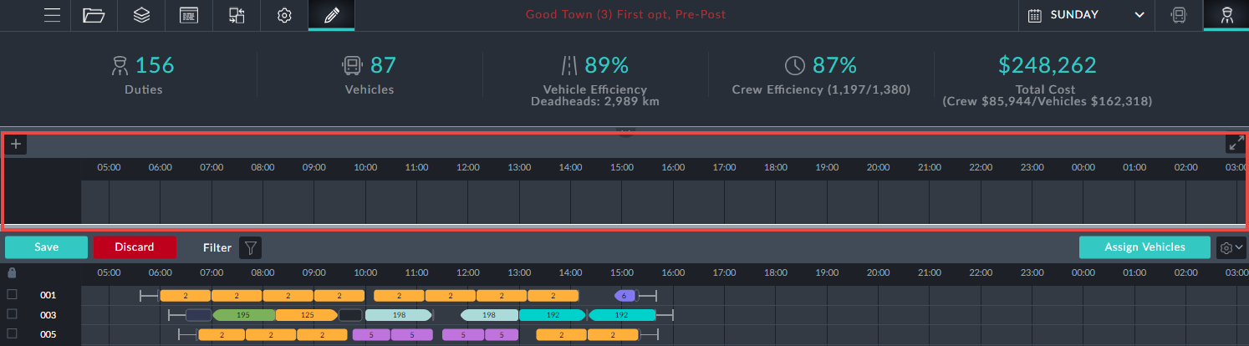

**Drivers Gantt Interactive Scheduling**

**What can be edited**

Trips start and end times may be edited

Trips may be removed

Pull out/pull in: Depot pull out origin and pull in destination can be changed

A taxi may be added, removed or replaced by a deadhead

Driver block information boxes offer editable fields: Driver ID and start/end locations for the duty.

**Moving a trip to another Duty**

You can move a single trip or a block of trips to another duty. You can also move them to a completely new duty.

***Moving a single trip***

We will move the red-boxed trip in duty 201 in the Drivers Gantt below to a different duty:

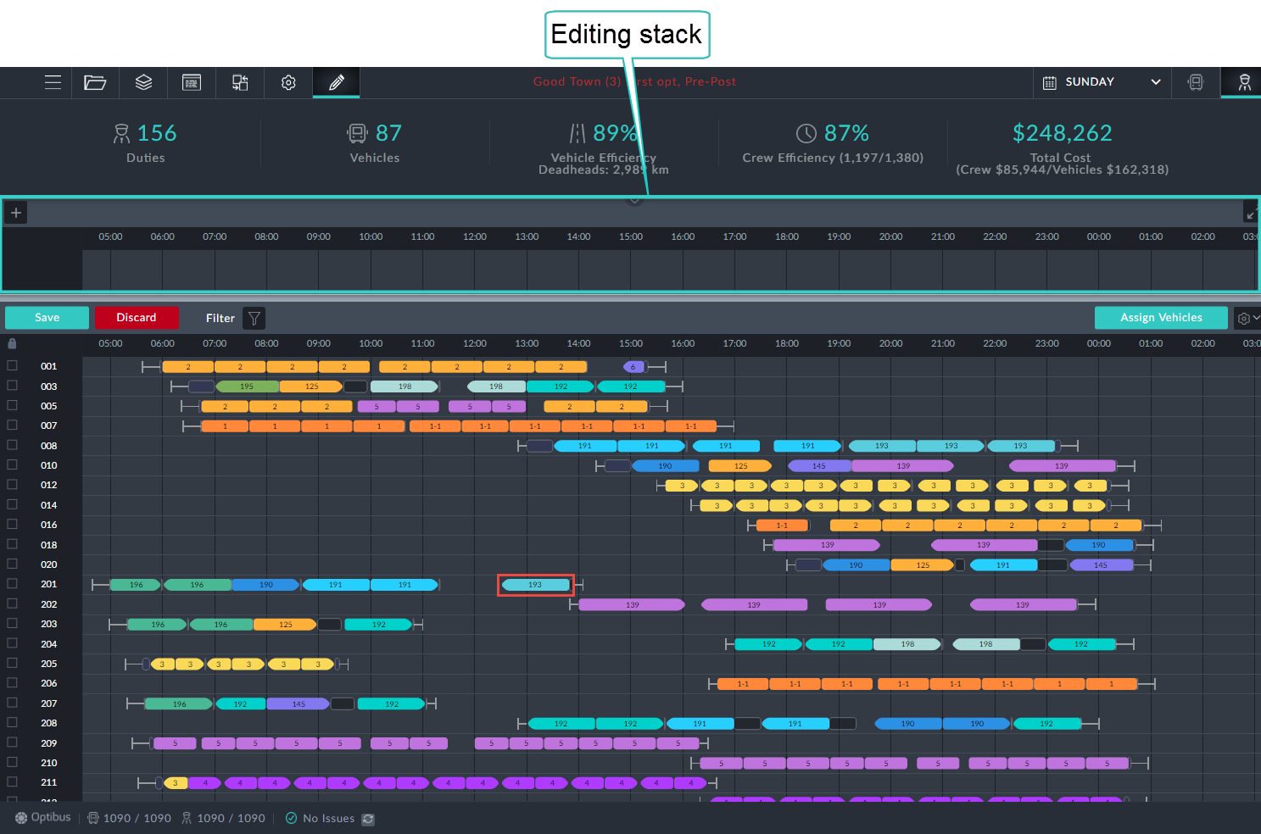

*Figure 9-1: Drivers Gantt prepared for manual editing*

Ø**To move a trip to another Duty:**

1. Enter Editing Mode as shown.

2. Double click the trip to be moved.

A shaded area including possible trip slots is displayed.

The system automatically recommends all possible options for relocation of the trip. There are two indications for each option:

A blue frame indicates that preferences are honored.

A red frame for an option indicates a violation of preferences. Inside the frame is a quality rating: 1 to 5 stars.

3. At duty 10 there is a slot with four stars in a red border. Click it to opens its

information box:

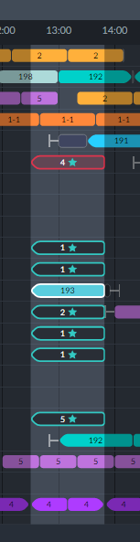

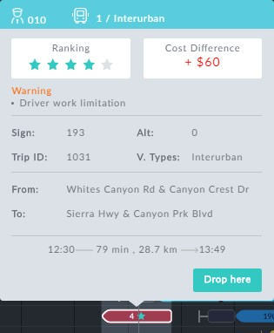*Figure 9-2: Left: Eligible slots; Right: Problematic red bordered slot: Work limitation*

*violation*

4. At the bottom of the eligible slots, there is one at duty 207 with a blue border and five stars. it is sufficient to double click it to move the trip.

Here is part of the changed Drivers Gantt showing the moved trip, shown in the red box. Notice also the new generated sign-off immediately after the trip.

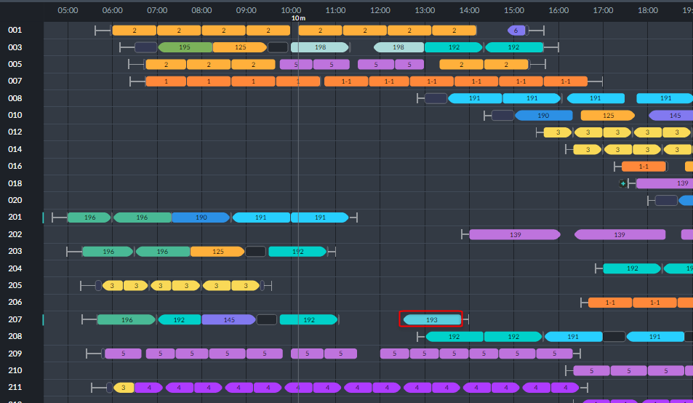

Notice also the light blue change-bar at the beginning of duty block 207.



All interactive edits will display a change-bar for altered duty blocks.

5. Click the **Assign Vehicles** button.

The change is commited to the currently open schedule. As usual you can disard or permanently save your changes to the schedule.



For advanced use of **Assign Vehicles**, see **Completing the Edit Session**.

If in step 4 above, we had chosen the red recommendation, the outcome would be dif-

ferent.

Ø**Moving a Single Trip with a Violation:**

1. (This replaces steps 4 on, above.) Chose the red recommendation shown in **Figure**

**9-2** above. Here is a segment of the Drivers Gantt:

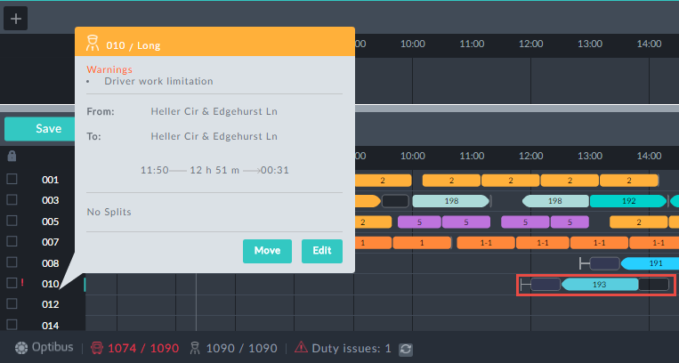

The moved trip is in the red rectangle. We have shown the driver block inform-

ation box - with a warning. Notice that a pre trip, pull out and and deadhead have also been added. In addition, there is a red warning sign next to Duty issues in the status line.

2. Click the Status line Duty issues area:

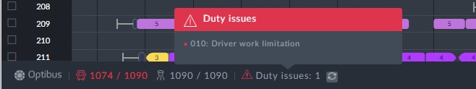

Again, a warning is posted for driver 10.

3., click the **Assign Vehicles** button to complete the changes.

***Using the Editing Stack***

The editing Stack is the area indicated in **Figure 9-1**. Trips can be moved to the stack or moved from the stack to the schedule.

Ø**To move a trip to the editing stack:**

In the left side of ???, double click the stack will re-assign the trip and move it to the stack:

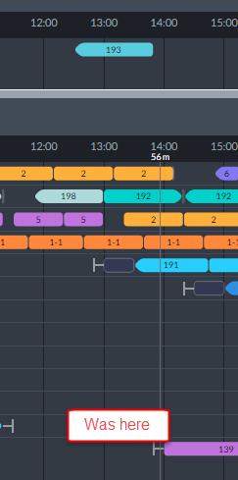

Ø**To re-assign a trip from the editing stack:**

1. Double click it

2. Click the target slot in the eligible trip slots:

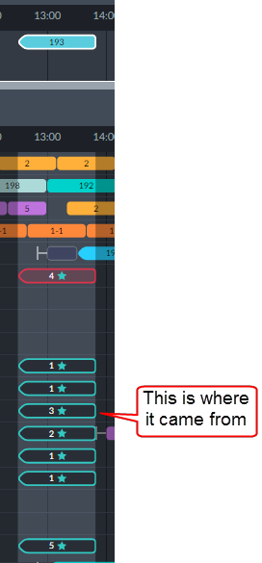

3. Click **Assign Vehicles** to commit your edits.

***Moving Multiple Trips to Another Duty***

Moving multiple trips works the same way as moving a single trip with one difference: Instead of selecting a single trip, you select a range. We demonstrate the method using the following Drivers Gantt segment:

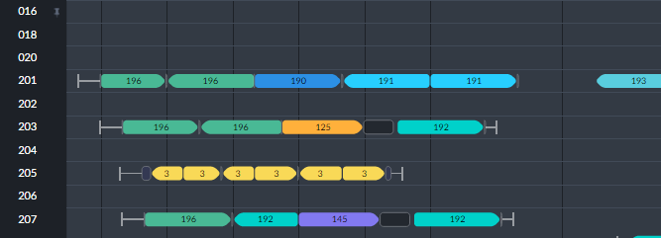

We will move the group of trips shown in driver block 203.

Ø**To move a group of trips:**

1. Click the first trip in block 203.

2. Shift-click the last trip in block 203.

The information box confirms your selection:

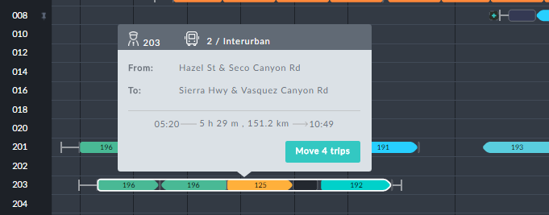

3. Click the green **Move** button.

The time range is highlighted and available slots are shown in the same manner as for moving a single trip.

4. Proceed in the same manner as for a single trip.



This method can only be used for blocks of contiguous trips

Moving multiple trips is a useful device for "cutting" a block of drips and

using them to create a new duty. See **Moving Trips to a New Duty**.

***Moving Trips to a New Duty***



We will use the example from **Moving Multiple Trips to Another Duty** to create a new duty.

Ø**To create a new duty in the drivers schedule:**

1. Scroll down to the bottom of the Drivers Gantt:

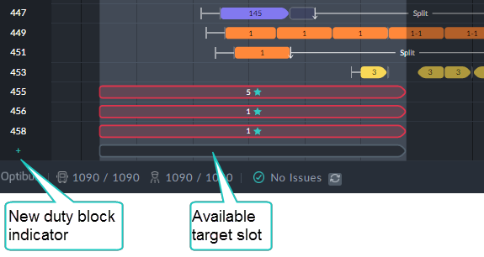

The blue + sign below the last duty (458) is a place-holder for a new duty.

2. Double click the slot in the new duty block. A new duty is generated with a temporary duty ID as shown:

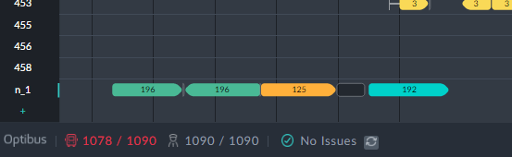

3. Click **Assign Vehicles**. Here is the outcome:

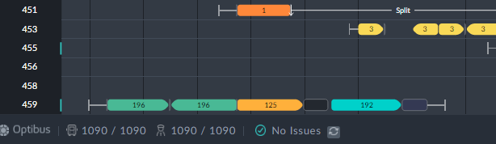

The new duty has been assigned ID 459 as expected. Also duty 455 has been mod-

ified as indicated by the change-bars. (No other duties in this schedule were affected.) As expected, an extra vehicle has also been assigned (not shown).

**Changing trip times**

To illustrate the procedure we will use duty 201 from ???. The first duty for the day is a trip on sign 196. Here is its information box:

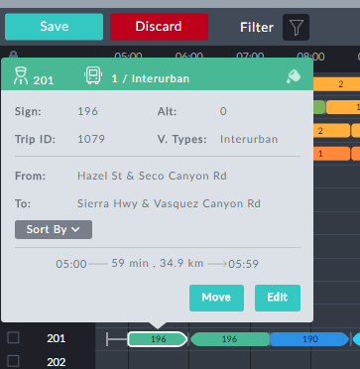

Suppose that it is found that on Sunday morning this trip has a delay of 7 minutes. We will edit this trip to reflect the situation.

Ø**To change the trip times:**

1. Click **Edit** in the information box:



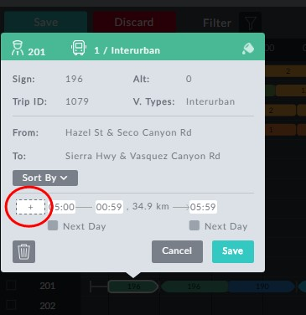

*Figure 9-3: Information box ready for editing*

All of the time fields are open for editing. In addition, the left hand time field (red circle) allows us to add boarding time by entering an earlier time than the shown trip start time.

2. By default it sets itself to the start time of 05:00. Enter 04:53.

3. Also extend the trip length by 5 min by increasing the shown length of 59 min to 64 min:

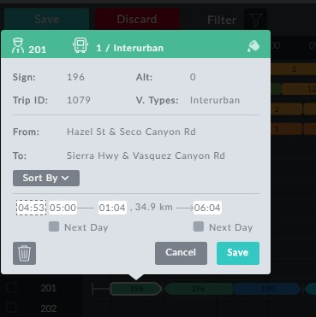

We could have changed the trip end time to 06:04 and the trip duration would have been updated.

In **Figure 9-4** below, observe that in addition to the change-bar, the changed trip

element has a black dot indicating that it has been manually changed. Notice also the red exclamation mark at the beginning of the row. It indicates a duty issue, that can be found from the bottom status line. Our edit has issued a warningas shown by the Duty Issues warning:

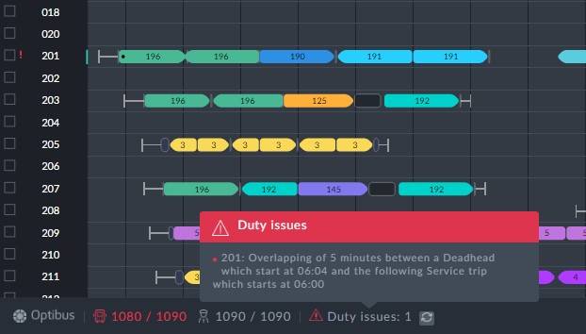

*Figure 9-4: Duty Issue caused by the edit*

5. Click the **Assign Vehicles** button to commit the edits.

**Deleting a Trip**

We will use the same example as in **Changing trip times** (the red-boxed trip in duty

201).

Ø**To delete a trip:**

1. Open the information box for the trip.

2. Click the  button.

3. Click **Save**. You are asked to confirm:

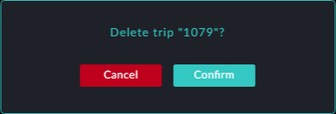

The trip is deleted from the Drivers Gantt:

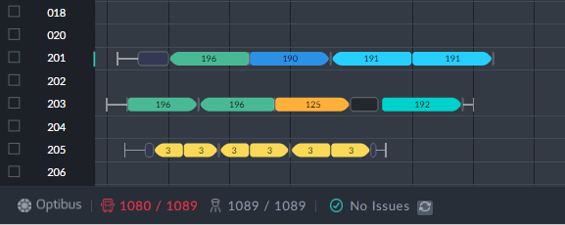

5. Click **Assign Vehicles** to commit the change.

**Changing a Depot Pull out/Pull in**

You can change a depot pull in destination or depot pull out origin at the end or begin- ning of a duty or at the beginning or ending of split break. We use a depot pull out as an example:

Ø**To change the origin of a depot pull out:**

1. Open the information box for the pull out to be changed.

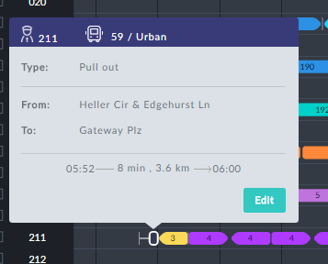

2. Click **Edit**.

3. In the Edit box click .

The pull out is removed from the Drivers Gantt.



4. Mouse-over the pre trip or the first trip of duty 211:



Notice the small blue + sign before the duty.

5. Click the + sign. The following dialog opens:

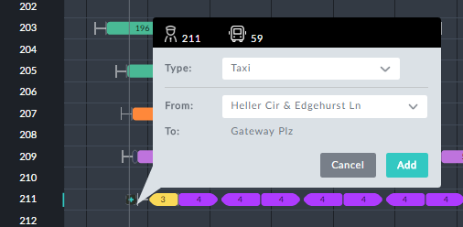

6. Click the **Type** field. A drop down list of abvailable types opens:

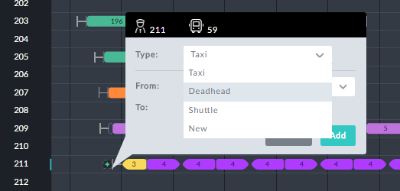

7. Choose Deadhead and then click the **From**: field:

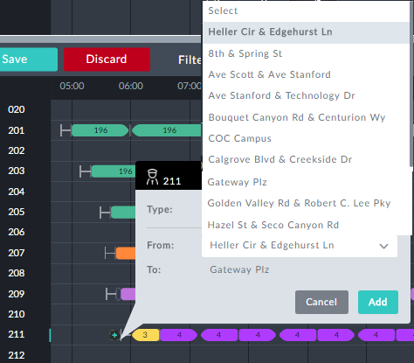

8. Choose COC Campus.

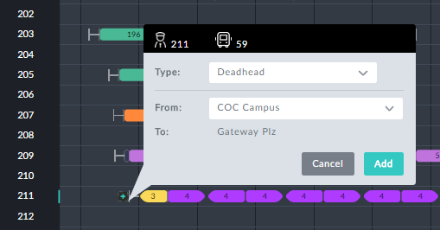

9. Click Add. The Pull out is added:

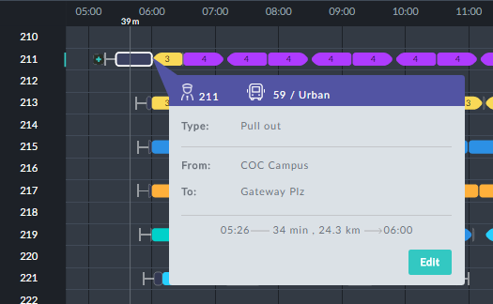

10. Click **Assign Vehicles**.



The same method is applicable to pull ins, pull ins before a split break and

pull outs after a split break.

**Adding and Removing a Taxi**

A taxi can be added to the beginning and end of a duty and the beginning and end of a split break. In the following example, we remove a Taxi (circled)from the beginning of duty 1:

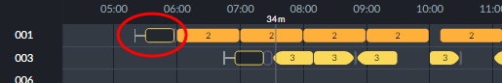

Ø**To remove a taxi:**

1. Click it to display its information box:

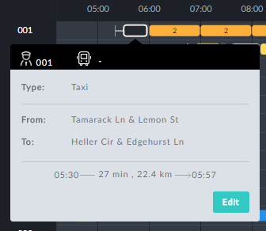

2. Click **Edit**.

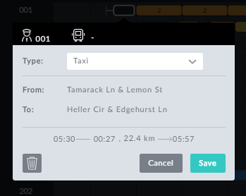

3. Click . The taxi has been removed:

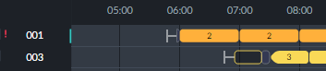

4. Click **Assign Vehicles**. Here is the Gantt segment:

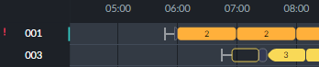

The red exclamation mark indicates a Duties issue. We will not go into it

here.

We next reverse the process and show how to add a taxi. We will add a taxi to the begin-



ning of duty 1.

Ø**To add a taxi:**

1. Mouse over the beginning of duty - the Sign on or first trip. You will see a little blue

+ sign:

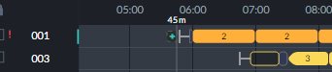

2. Click it. The following dialog opens:

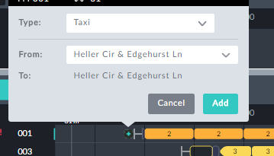

3. Leave **Type**: as is. **From**: opens a drop-down list of origins.

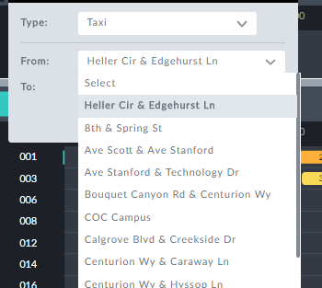

4. Choose COC Campusand click **Add**. The taxi is added:

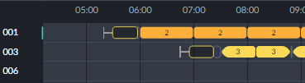

5. Click **Assign Vehicles**.

**Replacing a Taxi with a Deadhead**

It may be possible to replace a taxi with a deadhead (pull out or pull in) at the beginning or ending of a duty or a split break. Here is an example:

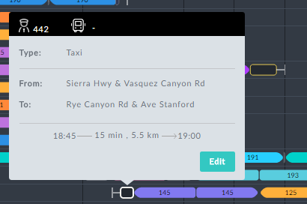

Ø**To replace a taxi with a deadhead at the beginning or end of a duty:**

1. Open its information box, as above.

2. Click Edit.

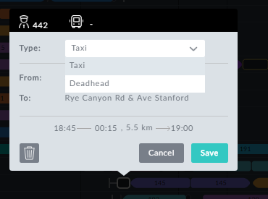

3. Change Taxi to Deadhead. Here is the result:

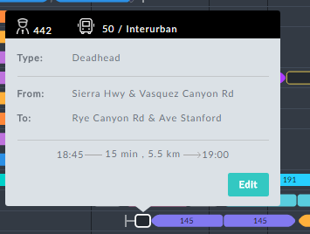

4. Click **Assign Vehicles**.

The situation at the beginning or end of a split break is similar. Here is an example:

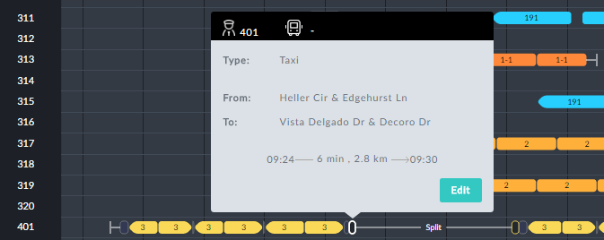

Notice that the indicated taxi follows a pull in.

Ø**To replace a taxi with a deadhead at the beginning or end of a duty:**

1. Open its information box, as above.

2. Click Edit.

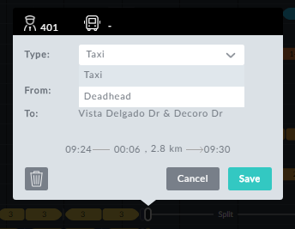

3. Change Taxi to Deadhead. Here is the result:



The taxi and the pull in have coalesced into a single pull in deadhead (circled).

4. Click **Assign Vehicles**.

**Custom Types and Elements**

You can create and use custom elements for the Drivers Gantt.

A custom element can be created / added anywhere on the Drivers Gantt between trips where a mouse-over open the little blue + sign.

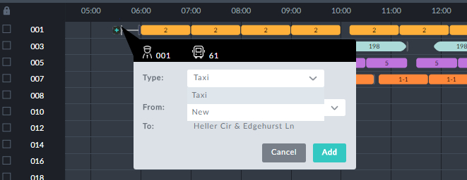

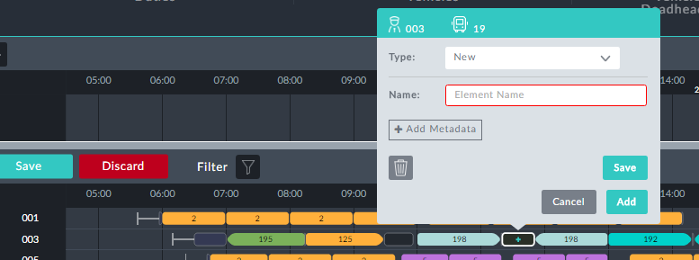

*Figure 9-5: Creating a custom element in an un-assigned gap*

By way of illustration, we will use the example to create several new element types, "Refuel" and "Standby". We then use the Refueling element type to create a refuel- ing break.

Ø**To create and use several new elements:**

1. Mouse-over a gap between two trips and click as in **Figure 9-5**
2. Choose “New” under Type

2. In the **Name** field, enter the name of the new element and click **Save**. The new type is saved and an information box is opened:

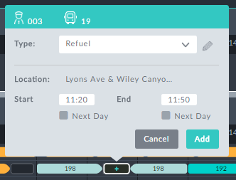

3. You can modify the times here - you do not have to assign the whole gap. Set the

**End** field to 11: 35

4. Click **Add**. Here is the result, with the information box opened:



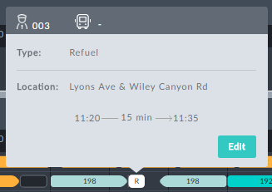

5. Mouse-over the remaining part of the gap and click it. The following dialog opens:

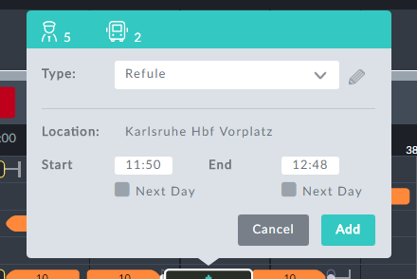

**Adding Metadata** is an expert mode function for use in conjunction with

Optibus Professional Services

We will turn this into a new Standby type.

6. Open the Type drop down list:

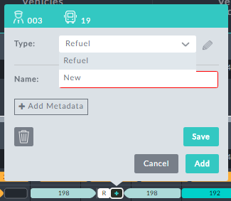

7. Choose **New**.

8. In the **Name** field, enter "Standby":

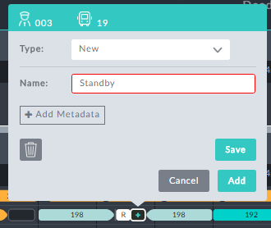

9. Click **Save**.

10. Save saves the new type. Add saves the type and adds a new element of the new type to the Drivers Gantt.

11. If you see this,



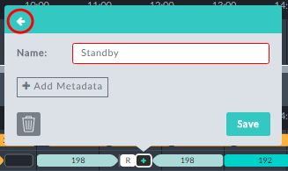

click the circled arrow.

You can use this box to rename the type to something else, for example,

"Standby (special)". Clicking **Save** commits the change for this case and takes you to the next step.

An editable information box for the remaining part of the gap is displayed:

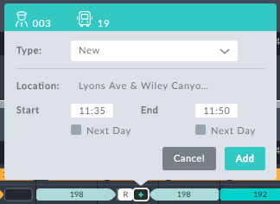

12. Open the **Type** drop down and choose Standby:

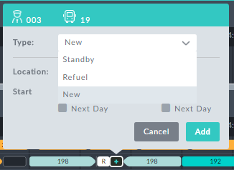

13. Click **Add**. Here is the outcome (with the information box opened):

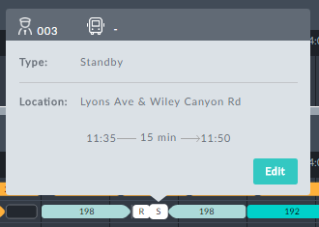

At any point the two new elements, "Refuel" and "Standby" are available. Mouseing-over any other gap and opening its information box shows something similar to this:

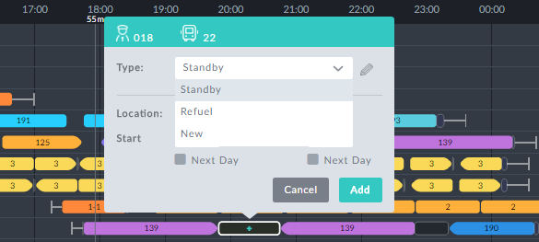

Proceed as above to add custom elements to the gap.

**Block level editing**

We will use the following Drivers Gantt segment (opened for editing), for illustration:

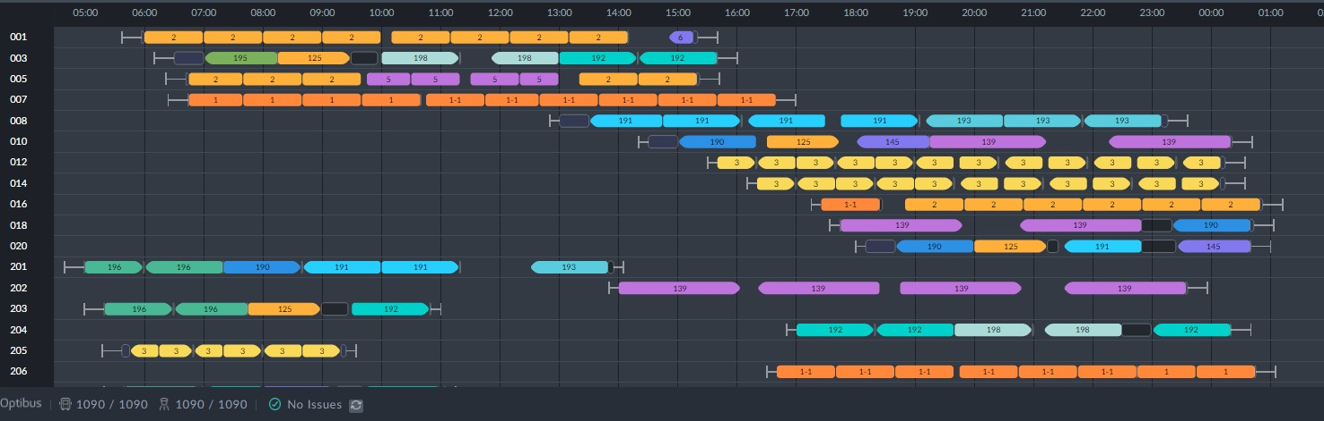

For driver 201, click the block to display its information box:

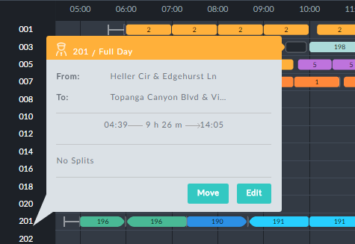

*Figure 9-6: Editing or moving a Driver block*

Click **Edit** to open it for editing:

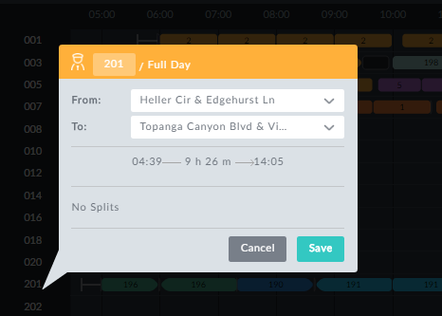

*Figure 9-7: Editing Driver block parameters*

***Changing a Duty ID***

In **Figure 9-7**, change the driver ID 20 2010 and save:

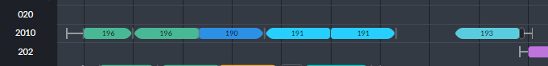

***Changing Duty Start/End stops***

The **From**: and **To:** fields are drop-down lists of eligible duty start and finish stops. Here for examples the **From** field:

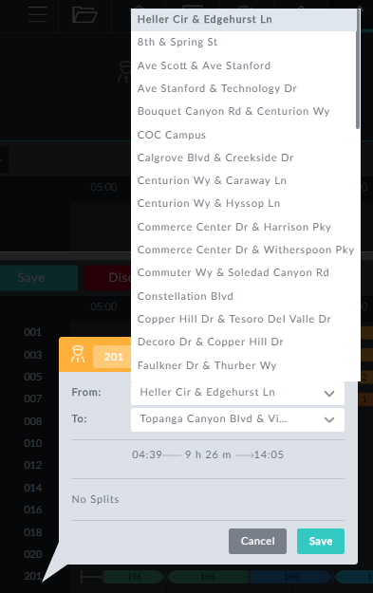

***Moving a block up or down***

In **Figure 9-6** click **Move**. A horizontal blue cursor line is displayed:

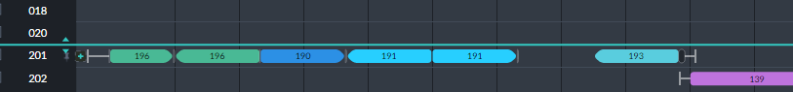

Moving the mouse up or down drags the cursor line. Drag it to between 203 an 204:

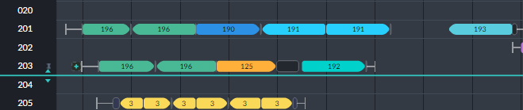

A double click effects the change:

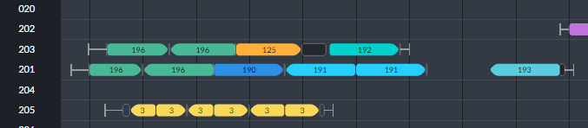

Moving a driver block is a convenient way of having it in a convenient pos-

ition on the screen. There is **no** need to click **Assign Vehicles**.

**Vehicles Gantt Interactive Editing**



**What can be edited**

Trips can start and end times may be edited

Trips may be removed

Vehicle block information boxes offer editable fields: Vehicle ID and vehicle type

**Changing trip times**

The method is the same as for changing Driver trip times. See Drivers Gantt: **Changing trip times**.

**Deleting a trip**

Deleting a trip is the same as for deleting a Driver trip. See Drivers Gantt: **Deleting a**

**Trip**

**Block level editing**

In the Vehicles Gantt, clicking a Vehicle block number opens the bock information box:

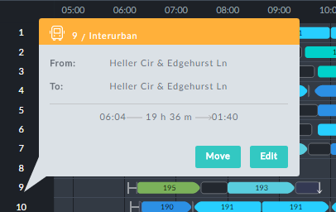

To open it for editing, click **Edit**:

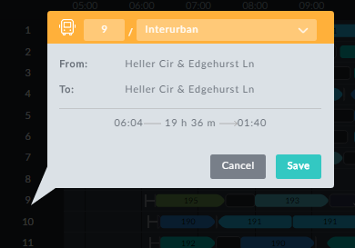

*Figure 9-8: Editing Vehicle block information box*

***Changing a Vehicle ID***

In **Figure 9-8**, you can change the Vehicle ID. You will be prevented from entering an ID

already in use. In this example, you could enter something like 9a.

***Changing a Vehicle Type***

Here you are offered a choice of Vehicle Types from those defined in the schedule.

***Moving a block up or down***

This feature works the same way as it does for Driver blocks. See Drivers Gantt: **Block level editing**

**Using a Vehicles-only Schedule**

**What can be edited**

Trips can start and end times may be edited

Trips may be removed

Pull out/pull in: Depot pull out origin and pull in destination can be changed.

Vehicle block information boxes offer editable fields: Vehicle ID and vehicle type

**Moving on or more trips to another Vehicle**

The method is the same as used in Drivers Gantt: **Moving a single trip** and **Moving Mul- tiple Trips to Another Duty**.

**Changing trip times**

Click a trip element for editing.

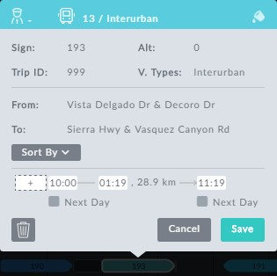

*Figure 9-9: Editing a vehicle through its information box*

Otherwise, changing trip start/end times works the same way as it does for Drivers Gant,

**Changing trip times**.

**Deleting a trip**

Deleting a trip works the same way as it does for Drivers Gant, **Changing trip times**.

**Changing a Depot Pull out/Pull in**

You can only delete these elements.

Ø**To delete a pull out:**

1. Open its information box:

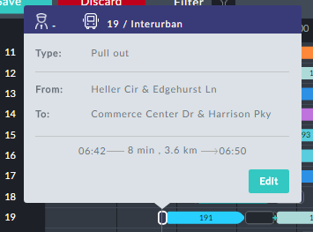

2. Click **Edit**.

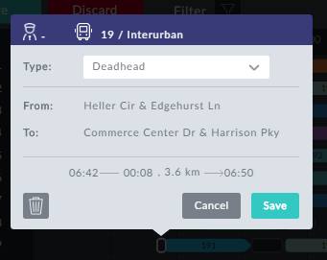

1. Click the  button. The pull out is deleted.
2. Add a new depot pull out…

**Custom Types and Elements**

Adding custom types and elements works the same way as it does for Drivers Gantt, **Cus- tom Types and Elements**

**Block level editing**

Block level editing works the same way as it does for Drivers Gant, **Changing trip times**.

**Using Add Trip**

**Add Trip** is available from the top of the Gantt display. To demonstrate the use of this feature, we start out with a segment of the Vehicles Gantt from the schedule we have used throughout this manual:

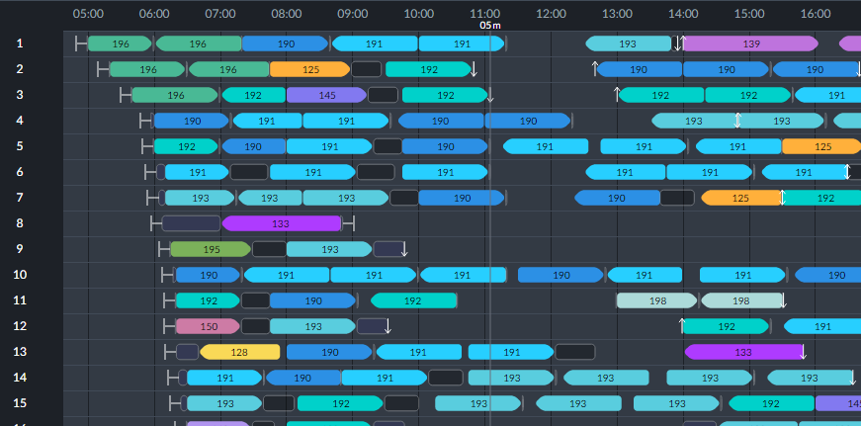

We will add an inter-urban trip for sign 192 at 10:35.

Ø**To add a trip:**

1. Click the plus sign button at the top left of the Stack area:

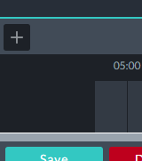

It opens up the following dialog:

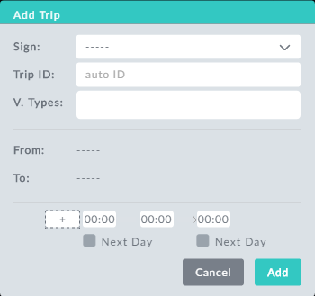

*Figure 9-10: Add Trip dialog*

2. Fill out the dialog, setting the direction, start time and trip duration.

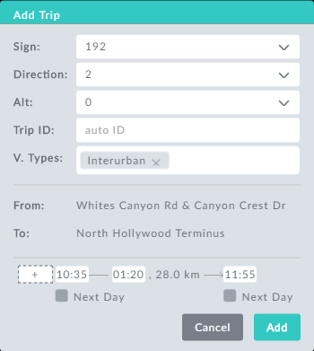

3. Click **Add**: The new trip in the editing stack ready for assignment:

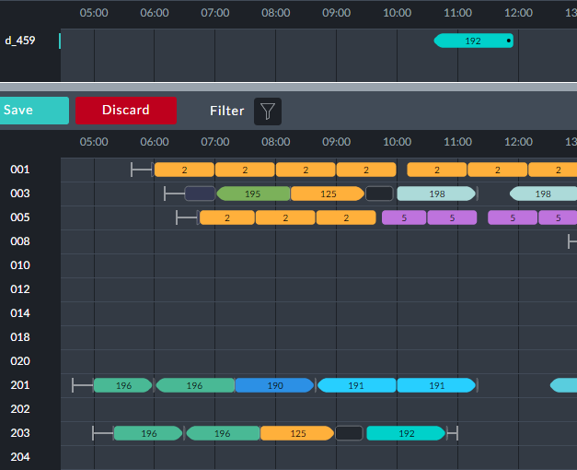

4. Double click the new trip in the editing stack.

5. From this point, proceed as in **Moving a trip to another Duty** and **Using the**

**Editing Stack**.

**Completing the Edit Session**

**Before Completing the Session**

Almost any change to the drivers schedule has some effect on the vehicles schedule. Con- sider the example in **Moving a trip to another Duty**:

Here is part of the changed Drivers Gantt showing the moved trip, shown in the red box. Notice also the new generated sign-off immediately after the trip.



The re-assignment affects the Vehicles schedule: In the Vehicles Gantt, vehicle 3, (which

is slotted to do the new trip) and also vehicle 1:

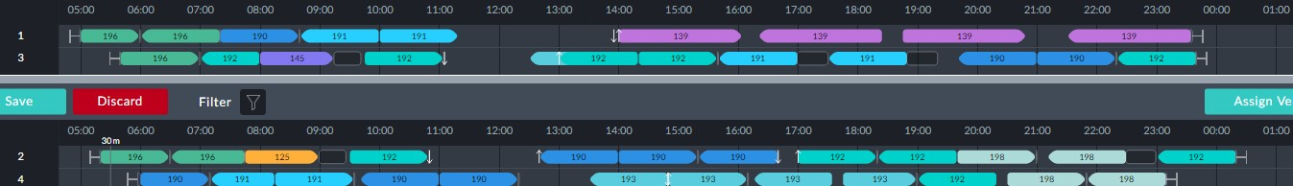

In the end vehicle 3 does not do it.

What you see in the edit stack are minimal vehicle schedule changes. In an **Assign Vehicles** run, the changes will flow to other vehicles. To see the actual result, click the **Assign Vehicles** button. We will not display it here. The new trip has been assigned to vehicle 88. An examination of the KPIs shows that the change has increased the vehicles count from 87 to 89.

**Using the Assign Vehicles Button**

To complete any interactive scheduling session, click the **Assign Vehicles** button. Advanced usage is available by opening button's context menu:

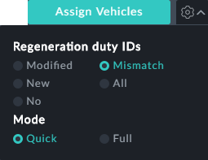

**Regeneration duty IDs**

If you have moved trips or added new elements you can choose to regenerate some or all of the duty IDs. You can choose between the following:

**Modified**: Regenerate duty IDs only for those duties that have been manually mod- ified

**New**: Regenerate duty IDs only for manually added duties

**No**: The duty IDs will stay the same. There is no regeneration.

**Mismatch**: Change as few duty IDs as possible provided that they conform to the system

ID generation rules. (Only non-conforming IDs are changed. See **Duty ID Generator**.)

**All**: Regenerate all of the duty IDs

**Mode:**

**Quick:** The system takes only the duties that have been “touched” and whose vehicles are in the stack (as in the example above) and assigns them with the rest of the duties to vehicles. It attempts to connect them with the other duties to assigned vehicles. It

is easier to recognize the changes when you are using the Quick mode. Use it when you do not want a major change in the vehicles schedule and in the appearance of the Drivers Gantt.

**Full**: The system takes all of the duties and assigns them to vehicles. It attempts to connect successive duties (one below the other in the Drivers Gantt) under the same vehicle. (This is how the manual option to move duties and reorder them can affect the vehicles assignment). Use this for the best results when you do not mind that the Gantts will change.